**COMPUTER SYSTEMS ARCHITECTURE**

**CENG356**

**Lab9**

Name: Wenzhong Zheng

SID: 823-405-386

Instructor: Maryam Davoudpour

Load/Store instruction.

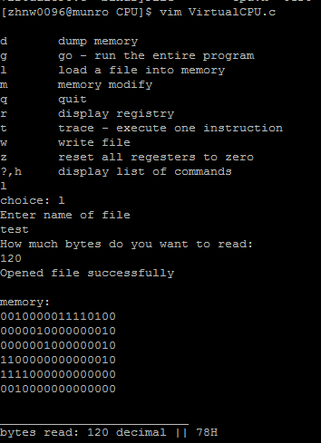

First load a binary file with a series of instructions, the first one says load F to R4

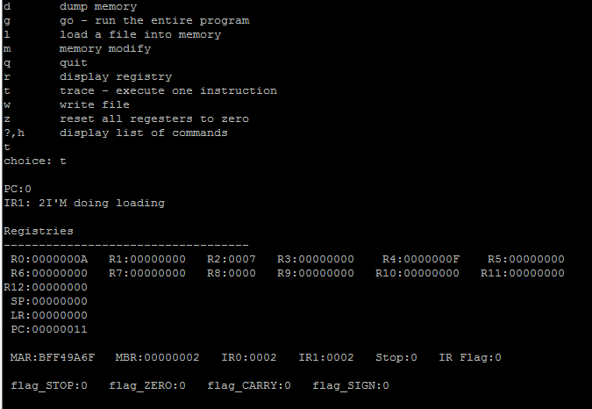

After I issue trace function, it execute the first instruction, which store the value F to R4

Stop instruction:

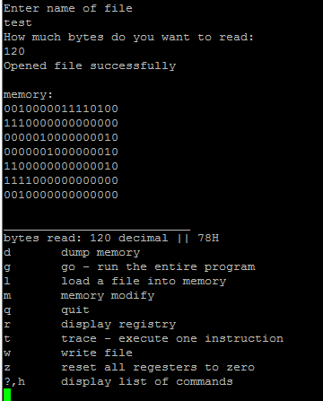

Load another file, with stop instruction on the second line.

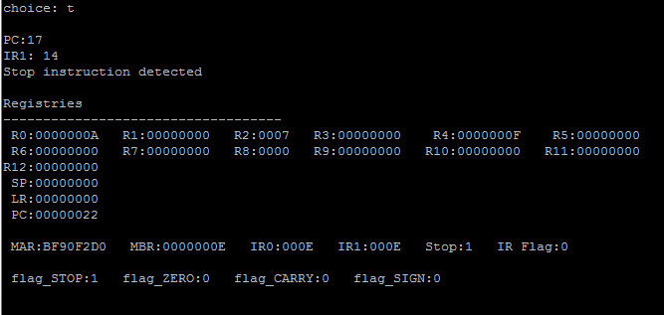

It detects the stop instruction, and set stop flag to 1

Code fragment:

//IR1=2 is Load/Store

if(IR1==2){

printf("I'M doing loading");

int code=fourBits(p,PC+4);

int *Rd= regNum(fourBits(p,PC+12));

int A=*Rd;

int B = fourBits(p,PC+8);

*Rd=B;

}

//IR1>=14 is stop instruction

if(IR1>=14){

printf("\nStop instruction detected");

flag_STOP=1;

}

//Carry flag setting

int isCarry(int x)

{

return x>MAX?1:0;

}